Given a binary tree, determine if it is

**height-balanced**

.

**Example 1:**

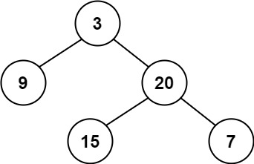

Input: root = [3,9,20,null,null,15,7]  
Output: true

**Example 2:**

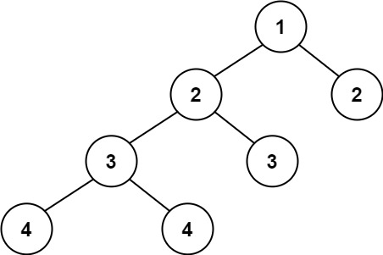

Input: root = [1,2,2,3,3,null,null,4,4]  
Output: false

**Example 3:**

Input: root = []  
Output: true

**Constraints:**

* The number of nodes in the tree is in the range [0, 5000].
* -104 <= Node.val <= 104